Installing OPM .NET6 Web API Template Version 1.8.0

## Dotnet CLI

If this is a first-time install, you must have Dotnet CLI installed.

1. To install the dotnet CLI you must install the .NET 6 SDK from here:
   1. <https://dotnet.microsoft.com/en-us/download>

## Uninstall Previous Version

If you have previously installed the version OPM WebAPI Template, you need to uninstall it.

1. Open a command window
2. Run this command:

dotnet new uninstall OPM.WebAPI.Template



## To install a new template

1. Unzip the template NuGet package - OPM.WebAPI.Template.1.8.0.zip
2. Open a PowerShell or Command Prompt windows
3. Change the directory into the folder when you unzipped the template package
4. Run the following Dotnet CLI command.

dotnet new install OPM.WebAPI.Template.1.8.0.nupkg - this will install the template

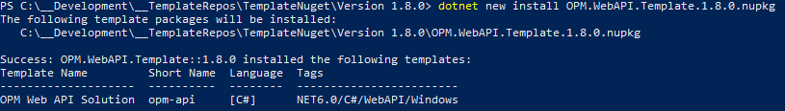

## Check Install

1. Run “dotnet new list “



1. Open Visual Studio 2022 and open the Start Window to create a new project

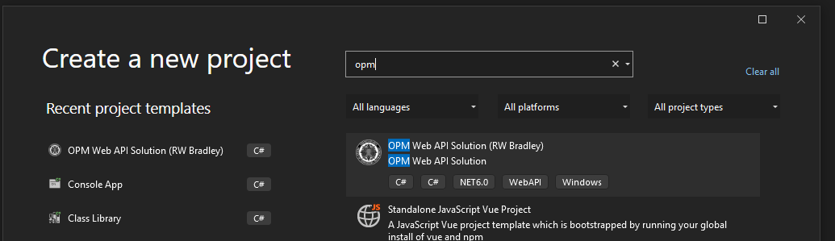

1. You may have to search for OPM when it is found, select it, and finish creating your new project.

You can also use Dotnet CLI to build the project.

To Create a Project

1. Change the directory to the folder where you want to create the project
2. Assuming your project name is “opm-test” you can create it using the PowerShell or Command Prompt window type:

dotnet new opm-api -o opm-test

